

QUARTERLY REPORT
Q3 2025

360 CAPITAL ITALIA SICAF S.P.A.
Investment Company with Fixed Capital – SICAF
Article 1, paragraph 1, lett.I-bis, d.lgs. No. 58 of 1998 ("TUF")

Page left blank intentionally

Table of Contents

1. Key figures as of Q3 2025 4
2. Management Company 5
3. Status as of Q3 2025 6
3.1 Summary 6
3.2 Financial performance 8
3.3 Cash flow schedule and net IRR calculation 9
3.4 Net asset value accounting 10
4. Portfolio Reporting as of Q3 2025 11
4.1 Portfolio summary as of September 30, 2025 13
4.2 Full realised portfolio summary as of September 30, 2025 14
4.3 Current portfolio 15
ENERGY DOME 16
CIRCULAR MATERIALS 16
SKILLVUE 16
TUNDR 16
RESILCO 16
KAMPAAY 16
GUIDOIO 16
INGAGE 16
MOVOPACK 16
NEWTWEN 16
SOOURCE 16
NEURONOVA 16
JAMPY 16
PHONONIC VIBES 16
ZEFI 16
ISAAC 16
TALENTWARE 16
VOIDLESS 16
EQUIXLY 16
CASAVO 16
5. Capital account as of September 30, 2025 17
6. Glossary 18

- Key figures as of Q3 2025

First closing date | September 15, 2022
Vintage year | 2022
Status | Investment Company with Fixed Capital
Management Company | 360 Capital Partners – Italian Branch
Investment policy | Italian start-up entities or mainly operating in Italy (from Seed to Late Stage) investments, with a general preference for sectors of Robotics, Artificial Intelligence, Big Data, Internet, E-commerce, On-line advertising and Mobile applications advertising, Digital Media and SaaS.
Currency  Total commitment | Euro  € 41.1 M
Hurdle rate | 0.20x
Total drawdown to date | € 27.1 M
Cumulative Drawdown B1 & B2 -Shares to date | 66.1%
Total distribution | € 0.0M
Net asset value | € 20.25M  A-share net value: € 0.010  B1-share net value: € 29.550  B2-share net value: € 29.550  C-Shares net value: € 0.000
Number of investee companies | 20
Total invested in portfolio companies | € 21.8M
Auditor | Deloitte, Italy
Custodian | CACEIS Bank, Italy Branch

- Management Company

Company | 360 CAPITAL PARTNERS  138 Boulevard Haussmann  75008 Paris  360 CAPITAL PARTNERS - ITALIAN BRANCH  Piazza Missori 2  20123 Milan  Mail: info@360cap.vc,  jeanmarie@360cap.vc  SIREN: 498 943 471
AMF’s authorization | GP11000040
Partners | Cesare Maifredi  Fausto Boni  Nader Sabbaghian  François Tison  Alexandre Mordacq
Website | http://www.360cap.vc

- Status as of Q3 2025

3.1 Summary
The SICAF invested € 0.32M to Phononic Vibes within a € 3M convertible note, together with 360 Polimi TT (€ 0.3M) and Fondo Parallelo LV 360 (€ 0.3M). Phononic Vibes develops patented metamaterials that control noise and vibrations through innovative physical design, delivering lighter, more sustainable, and higher-performing insulation solutions for infrastructure, mobility, and construction.
Additionally, the SICAF deployed € 1M in Ingage alongside POLI360 2 in a € 9.9M Seed round based on a pre-money valuation of € 13M. Ingage develops ultra-compact, high-precision MEMS inertial sensors that enable accurate navigation even in GPS-denied environments, targeting defense, robotics, and autonomous mobility markets.
The SICAF also made three follow-on investments:
- € 0.75M in Guidoio as part of a € 3.6M Series A round, alongside 360 Digitaly, based on a pre-money valuation of € 8M;
- € 1.2M convertible note in Energy Dome, together with Fondo Parallelo (€ 1.2M);
- and € 0.75M in Circular Material through a SAFE, participating in a total funding round of € 5.5M in which Fund V also invested the same amount.

Casavo NS ?

Latest news on our portfolio companies:
Energy Dome:
xx
Skillvue:
xx

Recent developments
The net asset value as of September 30, 2025, was calculated with information available as of date of this report.
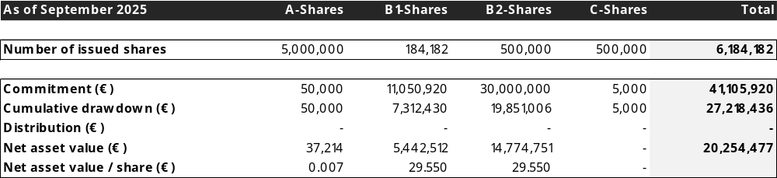

Drawdown/distribution

In Q3, the SICAF made its 12th capital call, bringing the total commitment called from B1 and B2 shareholders to 66.17% as of 30 September 2025.

Subsequent event

In October, 360 Capital led a € 3.15M Seed funding round for Adaptronics, with the SICAF contributing for € 1.1M, alongside Fondo Parallelo, which invested € 1.14M. This financing round was based on a pre-money valuation of € 10.34M
Adaptronics is an Italian deeptech startup specializing in electroadhesive technology for robotic gripping. Its core product, the Electro Active Adhesive Layer (EAAL), is a flexible film that uses electrostatics for strong, sensorized, and energy-efficient grasping. This technology allows robots to handle objects of any shape or material, making it ideal for industrial automation and space logistics.

3.2 Financial performance
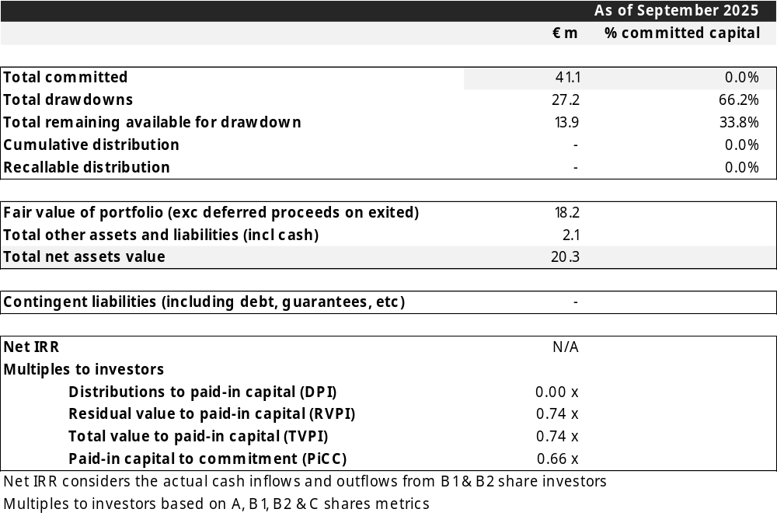

3.3 Cash flow schedule and net IRR calculation
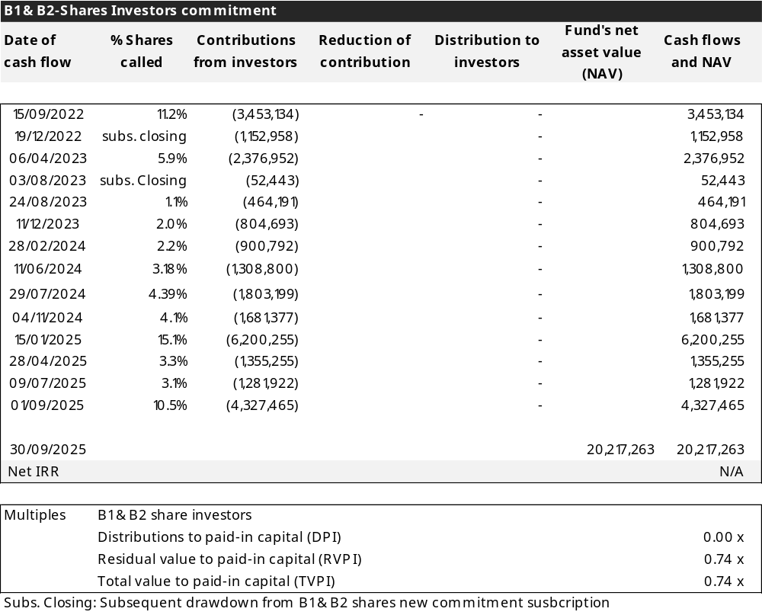

3.4 Net asset value accounting
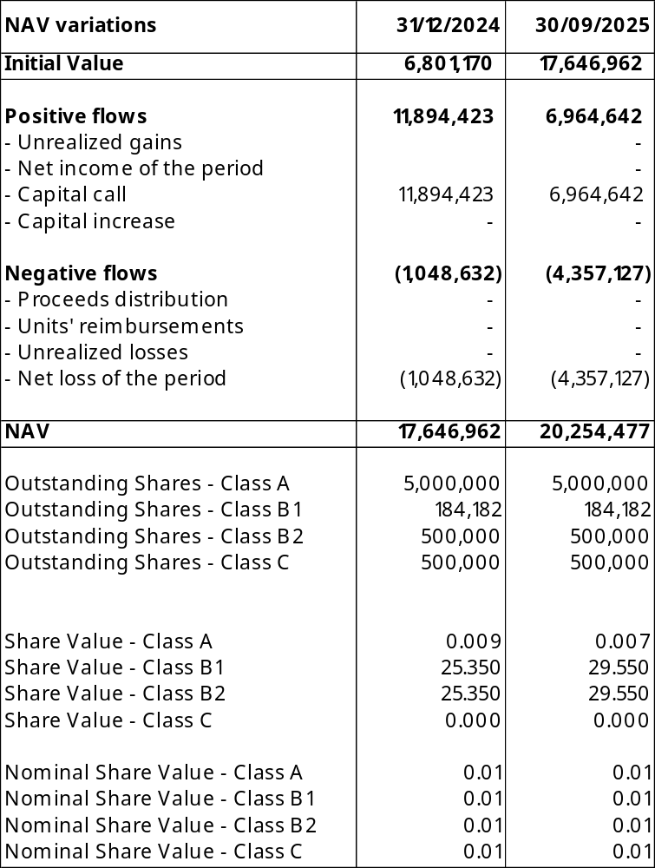

- Portfolio Reporting as of Q3 2025

Key Portfolio Events are detailed below.

- 2 new investments:

- Phononic Vibes: € 0.32M investment as part of a € 3M bridge financing round. This investment is a co-investment with 360 Polimi TT Fund and Fondo Parallelo LV 360.

- Ingage: € 1M investment as part of a € 9.9M Seed financing round, based on a pre-money valuation of € 13M. This investment is a co-investment with POLI360 2.

- 3 follow-on investments:
- Circular Materials: € 0.75M follow-on investment through a SAFE agreement, participating in a total funding round of € 5.5M together with 360 Fund V. The advisory board of the SICAF and the investor advisory committees of 360 Fund V and A+360 / 360 LIFE I agreed on a 50% pro rata split between the SICAF and 360 Fund V for this investment and all upcoming ones.
- Guidoio: € 0.75M follow-on investment in a Series A round of € 3.6M, based on a pre-money valuation of € 8M. This round was completed alongside 360 Digitaly.
- Energy Dome: € 1.2M investment through a convertible note, together with Fondo Parallelo LV 360, as part of a total round of € 38M.

Summary of main portfolio NAV variations

Casavo was fully depreciated due to a lack of liquidity, as the company was unable to generate sufficient cash flow and failed to secure additional financing to continue its operations.

Investments valuation method
The valuation criteria for equity investments in closed-end funds in unlisted companies are described by the Regulation of Bank of Italy published on 2015, Title V, Chapter IV, Section II, Paragraph 2.4.
According to the provisions of paragraph 2.4.1, the valuation of equity investments in unlisted companies, in the absence of reference prices expressed by the market, requires estimation considering a lot of elements. These procedures significantly influence the determination of the value of the fund.
Consequentially in the valuation of the assets, the value of them should reflect the economic, equity and financial conditions of the investee companies, considering these are investments made on a long-term basis. These provisions do not impose rigid uniform criteria, but delimit, with the indication of a series of operational criteria, an area within which the method considered most appropriate is chosen, according to an independent assessment.
As regards the general valuation criteria (par. 2.4.2), equity investments in unlisted companies are valued at purchase cost, but there are some exceptions described in the following paragraphs of the Regulation.
According to the provisions of paragraph 2.4.3 Investments in non-real estate companies, after a period which, as a rule, cannot be less than one year from the date of the investment, the securities of unlisted companies can be revalued based on the following criteria:
- Value resulting from one or more transactions, including capital increases, after the last valuation,
- Value resulting from the application of valuation methods based on economic-asset type indicators,
- Valuation, in the presence of companies that produce significant streams of income, from the methodologies of the price / earnings type, paying particular attention, however, that the ratio used is derived from a sufficiently large sample of companies like the one to be evaluated for type of production, economic and financial characteristics, development prospects and market positioning.
In addition, according to Bank of Italy regulations, in case of revaluation, a prudential measure due to illiquidity issues is to be considered, resulting in a 25% discount of the revaluation.

4.1 Portfolio summary as of September 30, 2025
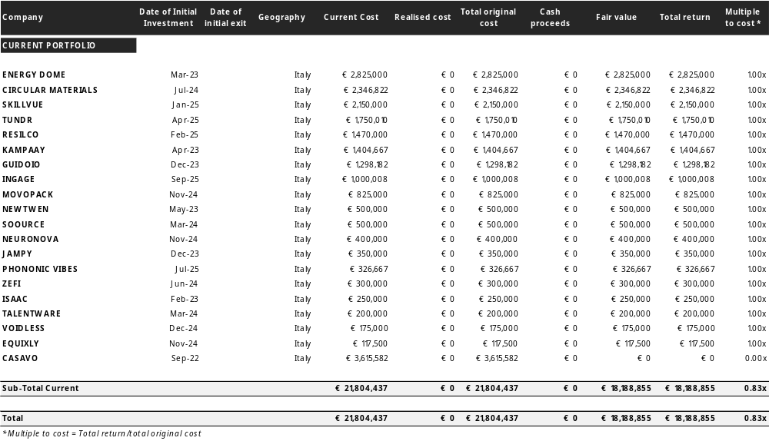

4.2 Full realised portfolio summary as of September 30, 2025
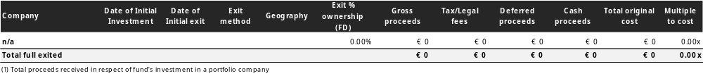

4.3 Current portfolio
- Energy Dome
- Circular Materials
- Skillvue
- Tundr
- Resilco
- Kampaay
- Guidoio
- Ingage
- Movopack
- Newtwen
- Soource
- NeuroNova
- Jampy
- Phononic Vibes
- Zefi
- Isaac
- Talentware
- Voidless
- Equixly
- Casavo

ENERGY DOME
CIRCULAR MATERIALS
SKILLVUE
TUNDR
RESILCO
KAMPAAY
GUIDOIO
INGAGE
MOVOPACK
NEWTWEN
SOOURCE
NEURONOVA
JAMPY

PHONONIC VIBES
ZEFI
ISAAC
TALENTWARE
VOIDLESS
EQUIXLY

CASAVO

- Capital account as of September 30, 2025

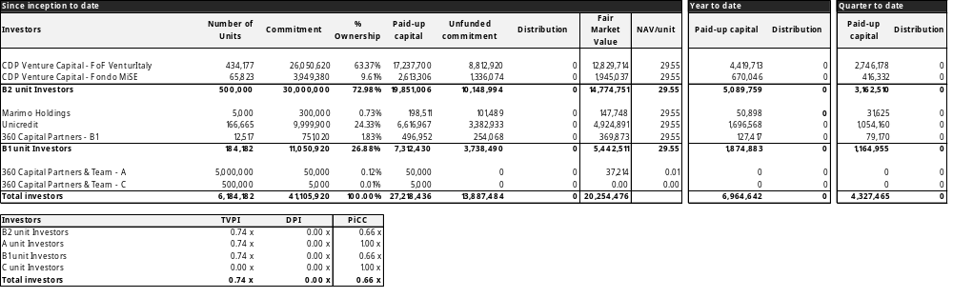

- Glossary

